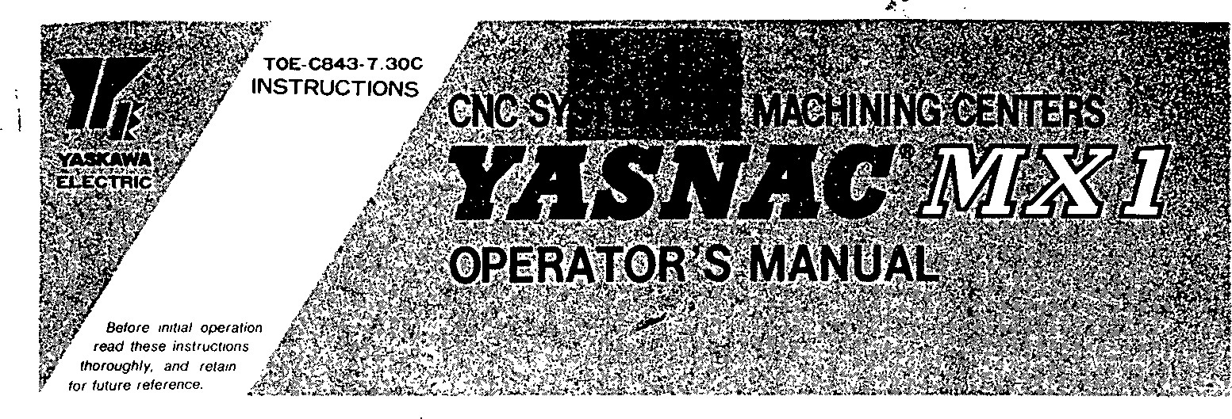

This manual is primarily intended to give operators instructions for YASNAC MXl programming, opera- tion and maintenance.

This manual applies to the basic and optional features of YASNAC MX1. The optional features are marked With a dagger. For the specifications of your YASNAC MX1, refer to the machine tool builder's manual.

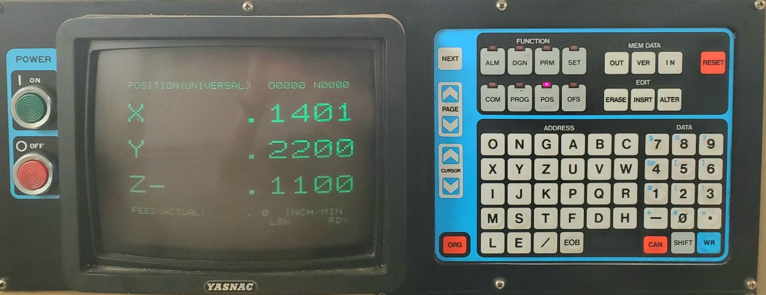

581-273

YASNAC MXI OPERATOR'S STATION